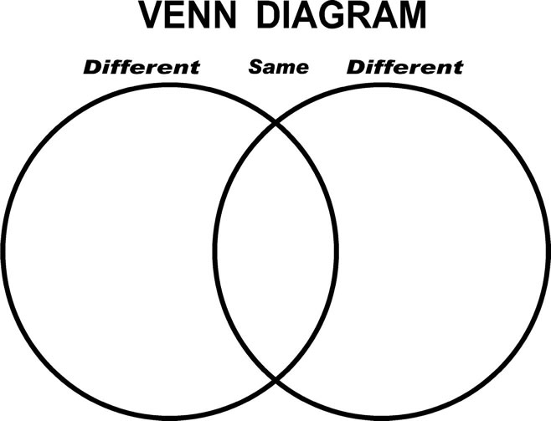

**All about Compounds**

* A compound is a ________________ substance composed of 2 or more elements that are ________________________ combined.
* Compounds - Have undergone a ______________________change
* Made up of __________________________called

__________________________.

**All about Compounds**

* Compounds have a Specific _______________– according to their masses – is always the same.
* If the _______________ changes, the _________________________ changes.

Examples:

* + H2O
  + NaCl
  + CO2

**What We Know:** Atoms & Elements

* We know- that ____________ are the smallest parts of elements.
* We know- that those elements are organized on the _________________________ by specific ________________________.
* We know- that all atoms of an element have the same number of _________________ in the nucleus.

**Atoms like to *share* Electrons**

* This takes ________________
* This _______________ them together
* This creates a new substance, called a _________________________ .