Motion Vocabulary
Essential Questions: When is an object in motion?
Complete one of the tasks below with the following vocabulary words:
Motion, Reference point, International System of Units, meter, Speed, average speed, velocity, slope
NO MATTER WICH TASK YOU CHOSE, READ THE REQUIREMENTS FOR EACH CHOICE!

Vocabulary Cards  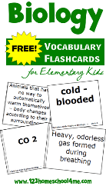  Create flashcards for each vocabulary word to help you learn the definitions. Include examples and pictures on your cards. The word on one side and examples and pictures on the other | Vocabulary Chart  Create a chart like this for all your vocabulary words. Put the words in alphabetical order!  Word Definition Sentence Example & picture | VOCABULARY QUIZ/TEST  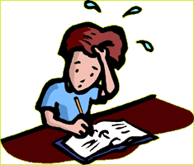  Create a test or quiz on the vocabulary terms. Be sure to include a variety of matching, fill-in-the-blanks and short answer. Must be neat and have an Answer Key included. Must include examples and definitions.
Vocabulary Bingo  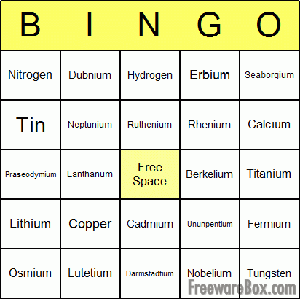  Create a BINGO game with the vocabulary terms. The words should go on the bingo board, while the clue cards would be definitions and examples that could be randomly drawn. | VOCABULARY ART  Create a children’s booklet that clearly illustrates and gives information on all the vocabulary terms. Must include definitions, examples, and pictures. This can be done as a story, comic, informational packet or other artistic format approve by the teacher! Could you take it next door to read to the pre K cubs? | Vocabulary RAP  Create a song or a rap that includes all the vocabulary terms with definitions and examples. Can you perform it?

